**Objective**

*The Client*

Dr. Sarah Hammer’s Chagas research group at TAMU did not have an interactive map that could be used by the public to access information about the presence of kissing bugs in Texas. After meeting with Dr. Hammer and Rachel Curtis, a PhD student in Dr. Hammer’s lab, it was agreed upon that Jannel and I would take on the development of this website as our Web489/689 class project.

*Client Relations*

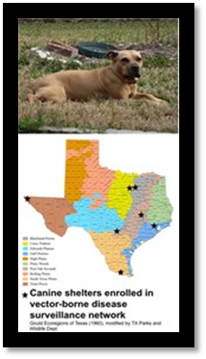Rachel Curtis was our point-person for the project. She was the authorized as the person to approve our recommendations for the website and signed off on our project proposal. Initially we met with her on a weekly basis. Mid-way through the project, we started to encounter challenges in programming so we switched from in-person meetings to email weekly updates so we could allocate more time to working on the project rather than in-person client relations. The client did not have any issues with switching the communication methods because we kept her informed of our progress. The client was very satisfied with the finished project.

*Client Needs*

Due to the large number of kissing bugs submitted to the lab by the general public, the lab wanted to enhance their current website map (see Figure 1) from a static website to an interactive website driven by a back-end database. The website would include an interactive web map where people who submit kissing bugs to Hammer’s lab could see the role that their submissions play in Chagas research throughout Texas. The following were the criteria for the website project: an interactive map at the county-level, using a pop-up window to display the total number of kissing bugs found by year (2012 and 2013) and by bug species (T. gerstaeckeri, T. sanguisuga, T. lecticularia, T. indictiva, and all bug species as the default). The website was to be updated monthly, using the client’s comma separate values (csv) file format.

Figure 1. Original Hammer Lab Kissing bug Web Site

**Architecture**

The project architecture is a 3 tier web-stack GIS application (see Figure 2). Each tier represents a separate component to the finished product, serving separate roles in the application functionality, with the physical location of that tier also being separate. The entire product 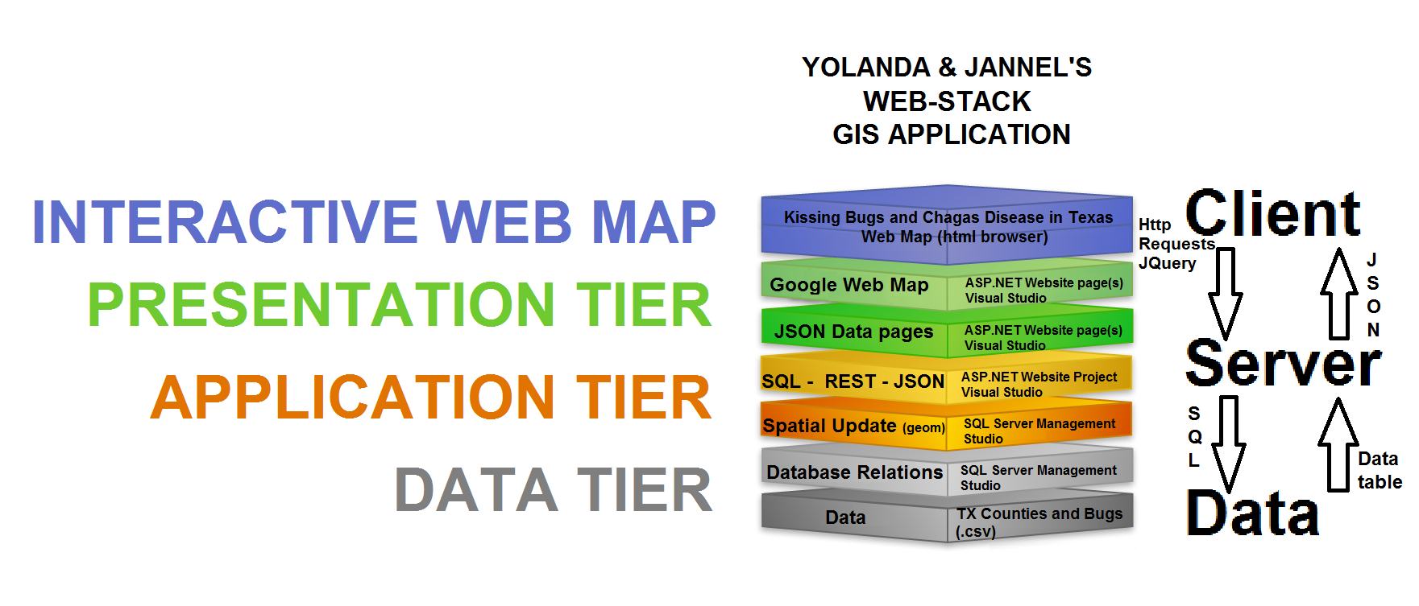

Figure 2. Project Web-Stack GIS Application

is hosted through a VMWare remote desktop, Windows 2008, and Internet Information Server. The I.P. address of hosting server is 128.194.26.182 and the domain name server where the web services are found is Geog489-03-tamu.edu. This architecture uses an .ASP.NET project in Visual Studio, with HTML and C# pages, Representation State Transfer (REST) style, and Structured Query Language (SQL) and JavaScript Object Notation (JSON) message formats to handle communication between the tiers. The data tier consists of the initial bug data and Texas County polygon files, as well as the database tables used for storing these data. The data format of file from the client and the Texas County polygons were (.CSV) comma-separated values. The client file included: a unique id, county, FIPS, month bug submitted, year bug submitted, bug species type, if the bug was tested for Chagas disease, and if the bug tested positive for Chagas disease. The database relations were created and stored data in SQL Server Management Studio. An update on the Well Known Text (WKT) column to specify its representation of a Geometric polygon object had to be done for it to be spatially aware in the database. The application tier is involved with data handling between the database and an HTML webpage. It uses an HTML, C# web-form and SQL commands to open and establish a connection to the database table. These pages read the table values and are structured to output the contents into strings of text in JSON format. The Presentation tier consists of HTML and REST-ful Web map services (<http://support.sas.com/documentation/cdl/en/wbsvcdg/62759/HTML/default/viewer.htm#n0uxdl0ugxduw6n1gduq1rcbo7i5.htm>), which use HTTP requests and Google APIs to display data. We also used a Cascading Style Sheet (.CSS) to control the webpage design. The Chagas Disease database relations and corresponding HTML Page to JSON Array information is documented in Appendix 1.

**Results**

The final product (<http://geog489-03.tamu.edu/workingchagas/kissingbug/_com/gmap.aspx/>) met the needs of the client (see Figure 3).

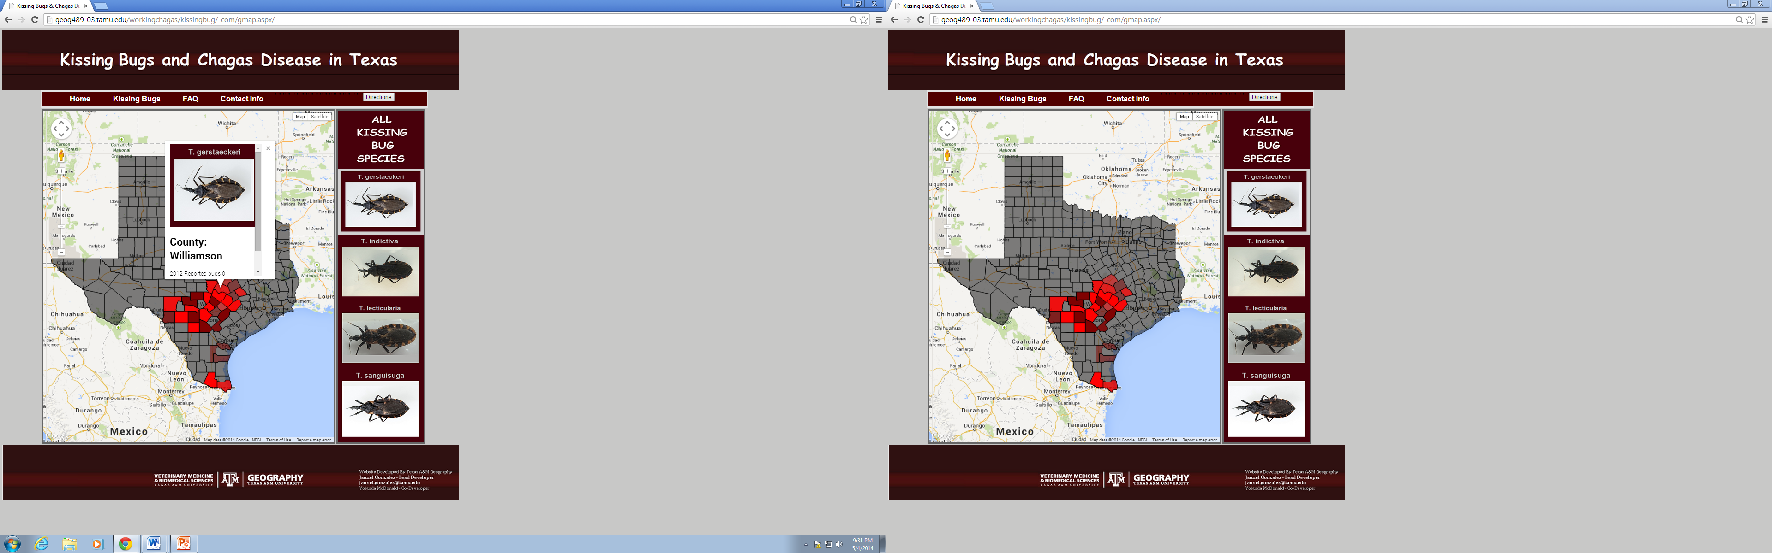

Figure 3. Kissing Bugs and Chagas Disease website (pop –up and non-pop-up view)

Significant milestones of the project included the database driven polygons for Texas (see Figure 4) and the species specific polygons (see Figure 5).

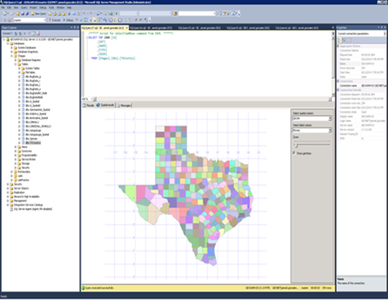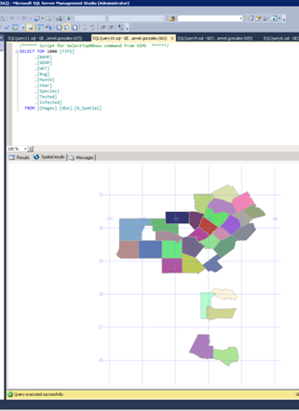

Figure 5. T. gerstaeckeri

Figure 4. Texas polygons

**Reflection**

*The Client*

Dr. Hammer and Ms. Curtis were pleased with the outcome. We did share with them that while the website did work, it did need further development to be more streamlined. In addition, the one element of the website that we did not accomplish was the choropleth gradient of the polygons.

*The Team*

Jannel and I worked closely together with Jannel taking on the role of lead developer. Jannel did all of the HTML and images for the website.

*The Challenges*

The project was more difficult than anticipated because we had to overcome three major roadblocks that we were not expecting. The first obstacle was creating the Texas polygons from a database source. Our initial data source for the Texas polygons was a Google Fusion table but after deliberation we decided that we could not utilize this resource because it did not meet the requirements of our client or the scope of our project requirements, i.e. a data driven website. Once we identified another source for the polygons, we manually transformed KML geography to a WKT format and created the Texas county spatial file. Because Raghu Modala team’s (Raghu and Yue) was at the same step as our team, in terms of building spatial polygons, we collaborated with them and developed a good working relationship. Mr. Modala was very helpful and allowed us to troubleshoot with him. We encountered an upload problem (could not upload a complete file) when using a set of HTML pages, with CSV parser and POST data, to send .CSV contents to the database table. We were not able to find documentation on why it occurred or how to fix it. However, we figured, there was some time-limit or other specification while reading the CSV or sending data to the database which would stop the completion. We did successfully upload all of the 254 counties, to create the Texas polygons, by separating the file into two and using both. The second major obstacle was establishing an HTTP request in our web map HTML page, which would access and read the county and bug data JSON pages. After trying to solve this, Dr. Goldberg identified that the issue was code in the aspx page that should not have been there. This auto-populated text was not visible to us from the launched webpage, but did affect the validity of our JSON arrays. Lastly, our third challenge was establishing a loop function and the required variables in the correct locations to read and handle the JSON bug data and then display information counts for individual county polygons. Unfortunately, Dr. Goldberg had to assist us with this challenge as well. Since then, Jannel has learned how to do this on her own and documented the structure of JSON text for future use (see Figure 6).

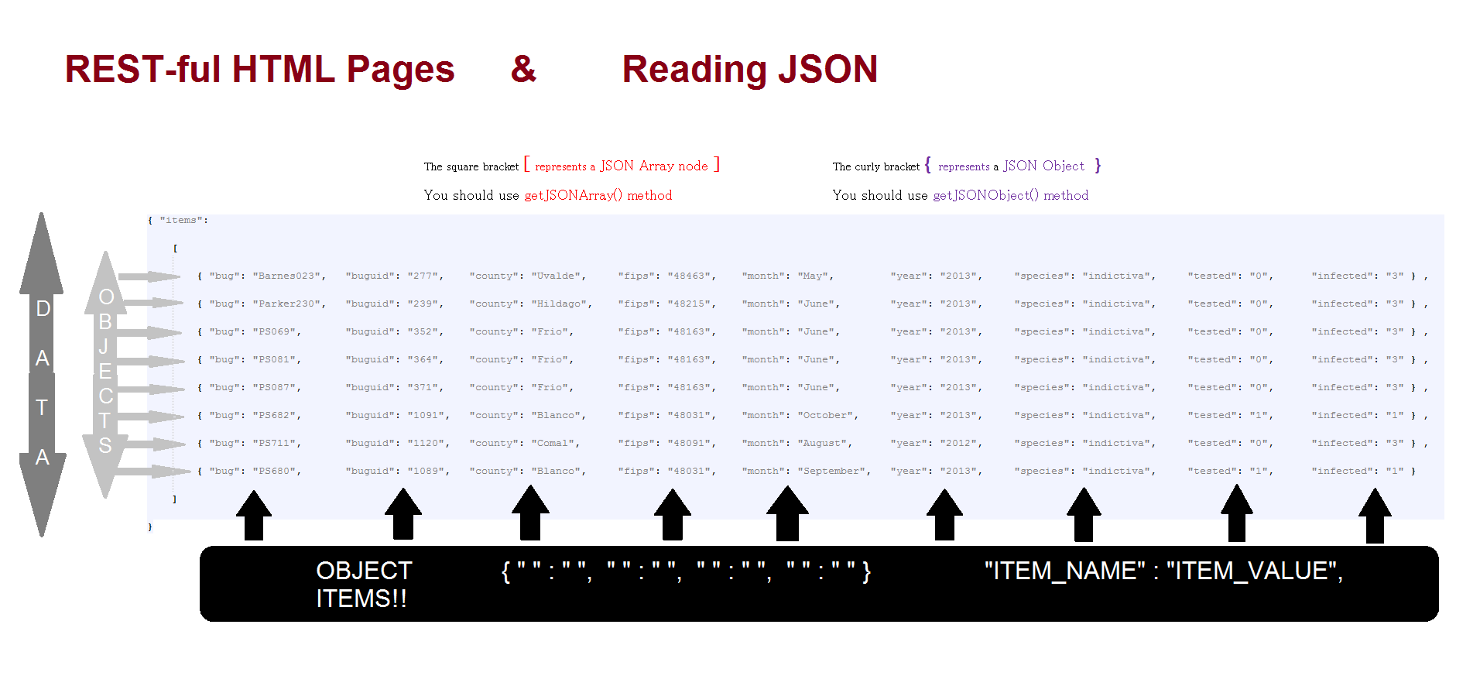

Figure 6. JSON Array Structure

**Project Wrap- Up/Final Thoughts**

We would be remiss not to state that this was a difficult project for us. It was frustrating to not make progress after investing hours working on the website. However, I believe that having a ‘real’ client forced us to work through our challenges, communicate honestly with each other, and seek assistance after we had exhausted other alternatives. As the project leader, I learned a great deal about working with undergraduate researchers and in hindsight I believe that if I would have had more advanced programming skills I could have been more of resource to Jannel.

Appendix 1

Chagas Database Relations & Corresponding

HTML Page to JSON Array Server Information

A * means that link is a JSON page used in the matching species map page or all of them

**dbo.BOLDname = Database relation name**(Column1, Column2, Column3, Etc)

**FIRST**   
-**Dbo.TXCountys** (ID, WKT, NAME, FIPS, GEOM)

<http://geog489-03.tamu.edu/WorkingChagas/Data/InsertCSV.aspx>

This link read our Texas Counties .CSV file & Requests the location of another HTML page to PUSH the data to database table – Below is the table we created for the County Data to input into

/*

*

* After creating a database called /*Table Name*\ , run this SQL command

*

* USE [ Chagas ]

* CREATE TABLE [dbo].[ TexasCountyPolygons ]

* (

* [Id] [int] IDENTITY(1,1) NOT NULL,

* [WKT] [varchar](max) NULL,

* [NAME] [varchar](50) NULL,

* [FIPS] [varchar](5) NULL,

* [Geom] [geometry] NULL)

* ON [PRIMARY] TEXTIMAGE_ON [PRIMARY]

* )

*

*/

<http://geog489-03.tamu.edu/WorkingChagas/GeoData/Push/PushCountyPoly.aspx>

The page above Will receive data from the Parse .csv page, and the above html page sends it to the data base

**<http://geog489-03.tamu.edu/WorkingChagas/GeoData/Get/countyshapes/GetCountyPolys.aspx>

The page above is the Final GET page for our Texas County Polygons – used to request data from database, write the data into JSON object array (item name & corresponding item values for each tuple or JSON object )& used draw on the grey (background) counties on all of our final maps

**-Dbo.BugDataNulls** (Bug, BugUID, County, FIPS, Month, Year, Species, Tested, Infected)

**-Dbo.LINKALL1** (FIPS, NAME, WKT, GEOM, Bug, Month, Year, Species, Tested, Infected)

JSON PAGES

<http://geog489-03.tamu.edu/WorkingChagas/GeoData/Get/SpatialResults/Default.aspx>

<http://geog489-03.tamu.edu/WorkingChagas/GeoData/Get/reports/Default.aspx>

**2ND TRYING TO FIND PROBLEM WITH**

**SPATIAL DATA NOT ALL SHOWING UP….**

**-Dbo.sanguisuga** (Bug, BugUID, County, FIPS, Month, Year, Species, Tested, Infected)

**-Dbo.G_Spatial** (FIPS, NAME, WKT, GEOM, Bug, Month, Year, Species, Tested, Infected)

**-Dbo.G_Spatial2** (FIPS, NAME, WKT, GEOM, Bug, Month, Year, Species, Tested, Infected)

**3RD REDO WITH DATA AFTER ELIMINATING**

**ALL TUPLES (ROWS) WITH NULL VALUES**

(except the Infected Column – changed all values having no value to a **3** – BC NO VALUE WASNT ‘NULL’, IT MEANT NOT TESTED)

**Dbo.BugDataNO_Nulls** (Bug, BugUID, County, FIPS, Month, Year, Species, Tested, Infected)

JSON PAGES

<http://geog489-03.tamu.edu/WorkingChagas/GeoData/Get/All_Bugs/GetBugs.aspx>

<http://geog489-03.tamu.edu/WorkingChagas/GeoData/Get/NotNullBugs/Default.aspx>

**Dbo.LINKEDALL_NONULLS** (FIPS, NAME, WKT, GEOM, Bug, Month, Year, Species, Tested, Infected)

Spatial join with TX Counties data on FIPS

JSON PAGES

** <http://geog489-03.tamu.edu/WorkingChagas/KissingBug/_com/allspecies.aspx>

<http://geog489-03.tamu.edu/WorkingChagas/GeoData/Get/NotNullSpatialResults/Default.aspx>

HTML MAP

<http://geog489-03.tamu.edu/WorkingChagas/KissingBug/_com/allmap.aspx>

BUG DATA BY SPECIES TABLES – NOT DIRECTLY USED, BUT MADE JSON PAGES FOR THEM ANYWAYS…

**Dbo.BugData_g** (Bug, BugUID, County, FIPS, Month, Year, Species, Tested, Infected)

JSON PAGES

<http://geog489-03.tamu.edu/WorkingChagas/GeoData/Get/G/Default.aspx>

**Dbo.BugData_i** (Bug, BugUID, County, FIPS, Month, Year, Species, Tested, Infected)

JSON PAGES

<http://geog489-03.tamu.edu/WorkingChagas/GeoData/Get/I/Default.aspx>

**Dbo.BugData_l** (Bug, BugUID, County, FIPS, Month, Year, Species, Tested, Infected)

JSON PAGES

<http://geog489-03.tamu.edu/WorkingChagas/GeoData/Get/L/Default.aspx>

Use Chagas

SELECT TXCountys.FIPS, TXCountys.NAME, TXCountys.WKT, TXCountys.GEOM,

BugData_s.Bug, BugData_s.BugUID,BugData_s.Month,BugData_s.Year, BugData_s.Species, BugData_s.Tested, BugData_s.Infected into Sanguisuga_Spatial

FROM TXCountys INNER JOIN BugData_s ON TXCountys.FIPS=BugData_s.FIPS ORDER BY FIPS

**Dbo.BugData_s** (Bug, BugUID, County, FIPS, Month, Year, Species, Tested, Infected)

JSON PAGES

<http://geog489-03.tamu.edu/WorkingChagas/GeoData/Get/S/Default.aspx>

BUG DATA BY SPECIES AFTER SPATIAL JOIN (inner join in SQL data base)

**Dbo.Gerstaeckeri_Spatial** (FIPS, NAME, WKT, GEOM, Bug, Month, Year, Species, Tested, Infected)

Spatial join with TX Counties data on FIPS

JSON PAGES

*<http://geog489-03.tamu.edu/WorkingChagas/KissingBug/_com/gspecies.aspx>

<http://geog489-03.tamu.edu/WorkingChagas/KissingBug/_com/gmap.aspx>

**Dbo.Indictiva_Spatial** (FIPS, NAME, WKT, GEOM, Bug, Month, Year, Species, Tested, Infected)

Spatial join with TX Counties data on FIPS

JSON PAGES

*<http://geog489-03.tamu.edu/WorkingChagas/KissingBug/_com/ispecies.aspx>

HTML MAP

<http://geog489-03.tamu.edu/WorkingChagas/KissingBug/_com/imap.aspx>

**Dbo.lecticularia_Spatial** (FIPS, NAME, WKT, GEOM, Bug, Month, Year, Species, Tested, Infected)

Spatial join with TX Counties data on FIPS

JSON PAGES

* <http://geog489-03.tamu.edu/WorkingChagas/KissingBug/_com/lspecies.aspx>

HTML MAP

<http://geog489-03.tamu.edu/WorkingChagas/KissingBug/_com/lmap.aspx>

**Dbo.Sanguisuga_Spatial** (FIPS, NAME, WKT, GEOM, Bug, Month, Year, Species, Tested, Infected)

Spatial join with TX Counties data on FIPS

JSON PAGES

* <http://geog489-03.tamu.edu/WorkingChagas/KissingBug/_com/sspecies.aspx>

HTML MAP

<http://geog489-03.tamu.edu/WorkingChagas/KissingBug/_com/Smap.aspx>

**Dbo.Species** (ID, proper_name, table_name)

JSON PAGES

<http://geog489-03.tamu.edu/WorkingChagas/GeoData/Get/Species/Default.aspx>